1. Team photos are very large. We asked for them to be in pairs or smaller.

They cannot be that big. They are the same size as the cards. The cards are the main part of the page. Photos cannot be so large in the mobile version.

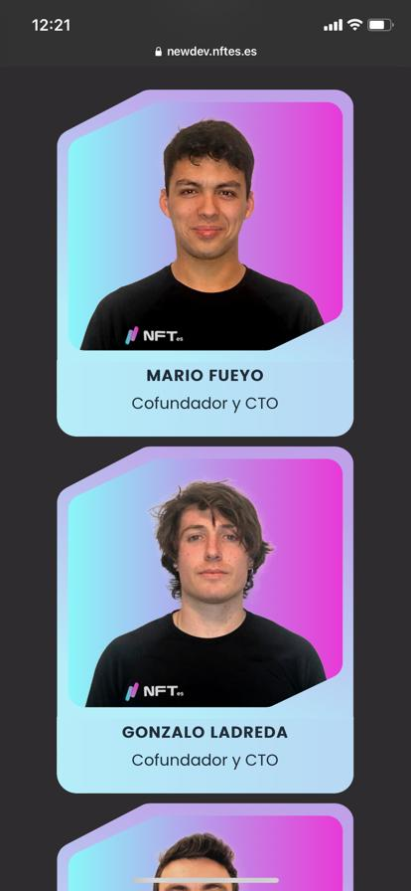

* 1. The positions and names are wrong: (NAMES THE SAME, NOT SOME CAPITALISED AND SOME NOT)

-Martín Agudo : Cofundador y CEO (first)

-Gonzalo Ladreda: Cofundador y COO (second)

-Mario Fueyo : Cofundador y CTO (3)

1. We need it to have less bottom margin. They should have the same margin and not be sdifferent.

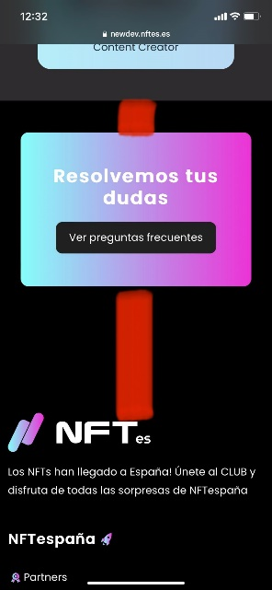

1. "333" above "NFTs".

3.1 The word is "NFTs" . (Not NFT) is plural.

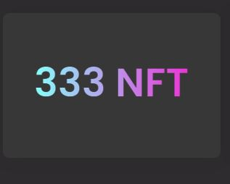

1. Delete the sentence underlined in blue (repeated)

**4.1**- The Word is “CLUB NFTespaña” (the letter C is missing)

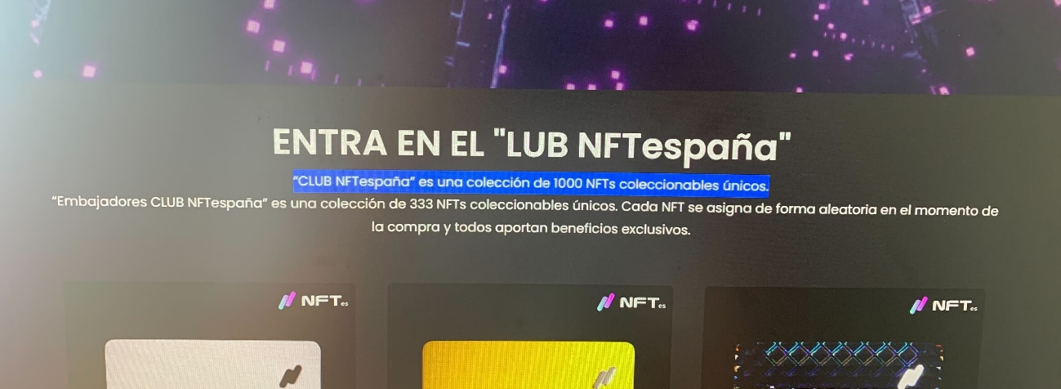

**4.2-** This text has to remain in 3 lines:

*1 headline*: Entra en el "CLUB NFTespaña"

*2 line:* “Embajadores CLUB NFTespaña” es una colección de 333 NFTs coleccionables únicos.

*3 line:* Cada NFT se asigna de forma aleatoria en el momento de la compra y todos aportan beneficios exclusivos.

1. Mobile version: when touching the drop-down it stays open and does not close again.

This takes up web space and should close after use.

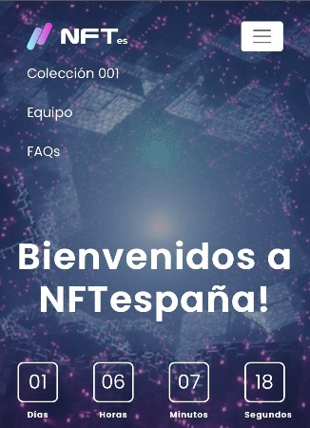

1. The cards (the NFTs) are wrongly selected.

The folder is called **NEW** and there you have the right 3 videos.

<https://cloud.mertyfx.com/s/qxx4d5T8ePQW94m?path=/NFT%20Animations/New&PC=OUTLIOS&FORM=OUTLSB>

1. In the footer:

-Policies do not lead to the texts we pass on to you.

-The discord has a broken link, put this one: <https://discord.gg/zzm2K8Pm>

-The icon and link to YouTube is missing as we designed in figma: <https://www.youtube.com/channel/UCVvv31Ps-8Tbk5o6eZoxEiA?sub_confirmation=1>